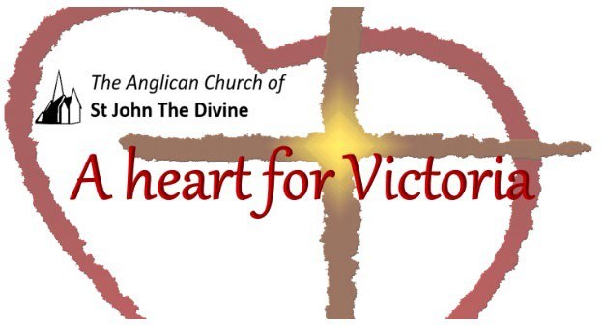

Wednesday July 21st 2021

Lunchtime Worship

St. John’s acknowledges that the Church buildings, and all living in Victoria, are on the ancestral lands of the Lekwungen speaking people.

Gathering to worship
Let us worship the Divine: Creator, Word and Spirit
All Amen

God is with you
All And also with you.

This is the day that the Divine has made
All We will rejoice and be glad in it. Opening Prayer
All Lord, direct our thoughts, and teach us to pray.
Lift up our hearts to worship you in spirit and in truth Amen
Blessed is the Creator
All for God has heard the voice of our prayer.

Psalm 100

. For giving grateful praise.
1 Shout for joy to the Lord, all the earth.
2 Worship the Lord with gladness;
come before him with joyful songs.
3 Know that the Lord is God.
It is he who made us, and we are his[a];
we are his people, the sheep of his pasture.
4 Enter his gates with thanksgiving
and his courts with praise;
give thanks to him and praise his name.
5 For the Lord is good and his love endures forever;
his faithfulness continues through all generations.

The Collect of the day:
Lord of all power and might,
the author and giver of all good things:
graft in our hearts the love of your name,
increase in us true religion,
nourish us with all goodness,
and of your great mercy keep us in the same;
through Jesus Christ your Son our Lord,
who is alive and reigns with you,
in the unity of the Holy Spirit,
one God, now and for ever.

Prayer

When evil darkens our world, give us light. When despair numbs our souls, give us hope. When we stumble and fall, lift us up. When doubts assail us, give us faith. When nothing seems sure, give us trust. When ideals fade, give us vision. When we lose our way, be our guide! That we may find serenity in Your presence, and purpose in doing Your will.

John. D Rayner

Affirmation

With people everywhere
All We affirm God’s goodness at the heart of humanity Planted more deeply than all that is wrong

With all creation
All We celebrate the miracle and wonder of life.
The unfolding purposes of God, forever at work In ourselves and the world
Iona Abbey Worship Book

Our prayers;

For those who are particularly vulnerable, We pray for safety and protection.

For all who experience fear or anxiety, We pray for peace of mind and spirit.

For affected families who are facing difficult decisions between food on the table or public safety, We pray for policies that recognize their plight.,
We pray that no family will face financial burdens alone.

For those who are afraid to access care due to immigration status, We pray for recognition of the God-given dignity of all.

For our brothers and sisters around the world, We pray for shared solidarity.

For public officials and decisionmakers, We pray for wisdom and guidance.

For those troubled with the choices that have to be made in this pandemic, grant them strength of purpose and mind to make decisions that benefit everyone and lead to returning to a safe and open lifestyle.

During this time may your Church be a sign of hope, comfort and love to all. Grant peace.
Grant comfort. Grant healing.
Be with us, Lord. Amen.

Gracious God,
All accept these prayers
In the name of our brother, Jesus Christ.

All Amen.

Eternal Spirit,
Earth-maker, Pain-bearer, Life-giver,
Source of all that is and that shall be,
Father and Mother of us all,
Loving God, in whom is heaven:
The hallowing of your name echo through the universe!
The way of your justice be followed by the peoples of the world!
Your heavenly will be done by all created beings!
Your commonwealth of peace and freedom
sustain our hope and come on earth.
With the bread we need for today, feed us.
In the hurts we absorb from one another, forgive us.
In times of temptation and testing, strengthen us.
From trials too great to endure, spare us.
From the grip of all that is evil, free us.
For you reign in the glory of the power that is love,
now and for ever. Amen.

The graduation of so many young people from high school or University starts a journey of exploration and realisation of the next step in their lives. We would like to share a poem which offers some thoughts and perspective.

A house called tomorrow, by Alberto Rios

You are not fifteen, or twelve, or seventeen—
You are a hundred wild centuries
And fifteen, bringing with you
In every breath and in every step
Everyone who has come before you,
All the yous that you have been,
The mothers of your mother,
The fathers of your father.
If someone in your family tree was trouble,
A hundred were not:
The bad do not win—not finally,
No matter how loud they are.
We simply would not be here
If that were so.
You are made, fundamentally, from the good.
With this knowledge, you never march alone.
You are the breaking news of the century.
You are the good who has come forward
Through it all, even if so many days
Feel otherwise. But think:
When you as a child learned to speak,
It’s not that you didn’t know words—
It’s that, from the centuries, you knew so many,
And it’s hard to choose the words that will be your own.
From those centuries we human beings bring with us
The simple solutions and songs,
The river bridges and star charts and song harmonies
All in service to a simple idea:
That we can make a house called tomorrow.
What we bring, finally, into the new day, every day,
Is ourselves. And that’s all we need
To start. That’s everything we require to keep going.
Look back only for as long as you must,
Then go forward into the history you will make.
Be good, then better. Write books. Cure disease.
Make us proud. Make yourself proud.
And those who came before you? When you hear thunder,
Hear it as their applause.

Thank you for spending this time with us.

Go in peace to love and serve.
All Thanks be to God. Amen.

Copyright acknowledgment
Order of service based on New Patterns for Worship © 2003
Some material included in this service is copyright: © The Archbishops' Council 2000
Some material included in this service is copyright: © The Archbishops' Council 2002 Sacred Space, 2020

