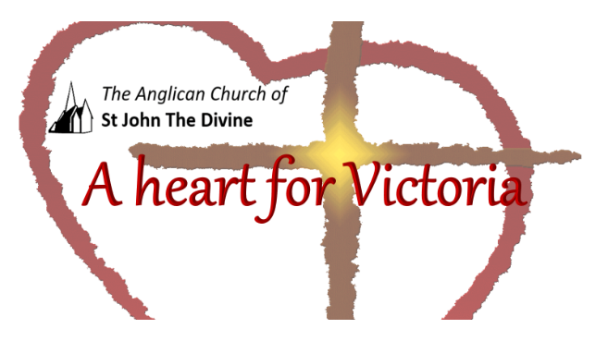

A Simple service during the day

Gathering to worship God

Greeting
Let us worship God: Creator, Word and Holy Spirit
All Amen

God is with you
All And also with you.

This is the day that God has made
All We will rejoice and be glad in it.

Welcome and introduction

Opening Prayer

All Lord, direct our thoughts, and teach us to pray.
Lift up our hearts to worship you in spirit and in truth,
through Jesus Christ our Lord. Amen

Praise
Blessed is the Creator
All for God has heard the voice of our prayer;

Readings (may include poetry etc)

Psalm

Psalm 67

The Nations Called to Praise God

To the leader: with stringed instruments. A Psalm. A Song.
¹ May God be gracious to us and bless us
and make his face to shine upon us, Selah
² that your way may be known upon earth,
your saving power among all nations.
³ Let the peoples praise you, O God;
let all the peoples praise you.
⁴ Let the nations be glad and sing for joy,
for you judge the peoples with equity
and guide the nations upon earth. Selah
⁵ Let the peoples praise you, O God;
let all the peoples praise you.
⁶ The earth has yielded its increase;
God, our God, has blessed us.
⁷ May God continue to bless us;
let all the ends of the earth revere him.

New Testament/Gospel: Luke 6:27-38

Love for Enemies
²⁷ “But I say to you that listen, Love your enemies, do good to those who hate you, ²⁸ bless those who curse you, pray for those who abuse you. ²⁹ If anyone strikes you on the cheek, offer the other also; and from anyone who takes away your coat do not withhold even your shirt. ³⁰ Give to everyone who begs from you; and if anyone takes away your goods, do not ask for them again. ³¹ Do to others as you would have them do to you.
³² “If you love those who love you, what credit is that to you? For even sinners love those who love them. ³³ If you do good to those who do good to you, what credit is that to you? For even sinners do the same. ³⁴ If you lend to those from whom you hope to receive, what credit is that to you? Even sinners lend to sinners, to receive as much again. ³⁵ But love your enemies, do good, and lend, expecting nothing in return.^{[a]} Your reward will be great, and you will be children of the Most High; for he is kind to the ungrateful and the wicked. ³⁶ Be merciful, just as your Father is merciful.

Judging Others
³⁷ “Do not judge, and you will not be judged; do not condemn, and you will not be condemned. Forgive, and you will be forgiven; ³⁸ give, and it will be given to you. A good measure, pressed down, shaken together, running over, will be put into your lap; for the measure you give will be the measure you get back.”

Affirmation of faith (optional)

With the whole church
All We affirm that we are made in God’s image,
Befriended by Christ,
Empowered by the Spirit

With people everywhere
All We affirm God’s goodness at the heart of humanity
Planted more deeply than all that is wrong

With all creation
All We celebrate the miracle and wonder of life;
The unfolding purposes of God, forever at work
In ourselves and the world
Prayers of Intercession
The prayers may include this response
God, in your love
All hear our prayer.
The prayers end with
Gracious God,
All accept these prayers
In the name of our brother, Jesus Christ.
Amen.
Collect (Prayer for the Day)

at the end
All Amen.

The Lord’s (Disciples’) Prayer – in this or other form
All Our Father in heaven,
hallowed be your name;
your kingdom come;
your will be done;
on earth as in heaven.
Give us today our daily bread.
Forgive us our sins,
as we forgive those who sin against us.
Save us from the time of trial
And deliver us from evil.
For the kingdom, the power
and the glory, are yours
now and ever. Amen.

Going out to serve God

Let us bless our Loving God
All thanks be to God.
Blessing, honour and glory be yours,
here and everywhere,
now and for ever.
Amen.
Go in peace to love and serve in the name of Christ.
All Thanks be to God. Amen.

Copyright acknowledgment
Order of service taken from New Patterns for Worship © 2003
Some material included in this service is copyright: © The Archbishops' Council 2000
Some material included in this service is copyright: © The Archbishops' Council 2002

