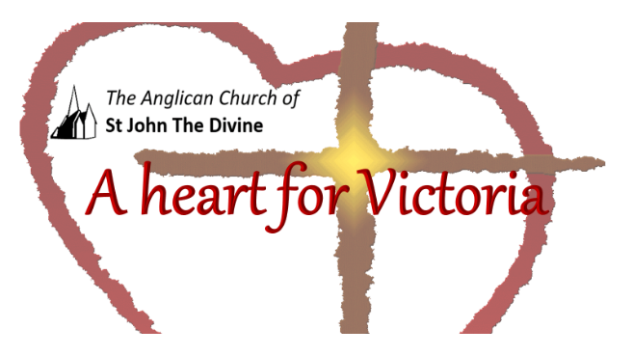

Wednesday, January 13th

Lunchtime Worship

St. John’s acknowledges that the Church buildings, and all living in Victoria, are on the ancestral lands of the Lekwungen speaking people.

Gathering to worship
Let us worship the Divine: Creator, Word and Spirit
All Amen

God is with you
All And also with you.

This is the day that the Divine has made
All We will rejoice and be glad in it.

Opening Prayer

All Lord, direct our thoughts, and teach us to pray.
Lift up our hearts to worship you in spirit and in truth
Amen
Blessed is the Creator
All for God has heard the voice of our prayer.

Psalm 91,1-2,4,9-12

¹ Whoever dwells in the shelter of the Most High
will rest in the shadow of the Almighty.^{[a]}
² I will say of the Lord, “He is my refuge and my fortress,
my God, in whom I trust.”
⁴ He will cover you with his feathers,
and under his wings you will find refuge;
his faithfulness will be your shield and rampart.

If you say, “The Lord is my refuge,”
and you make the Most High your dwelling,
¹⁰ no harm will overtake you,
no disaster will come near your tent.
¹¹ For he will command his angels concerning you
to guard you in all your ways.

Prayer

Creator God,
in love you have fashioned the human family
in a variety of races, languages, and cultures.
Do not let our diversity divide us,
but help us to welcome gifts
we can give and receive from one another.
Save us from prejudice, arrogance and fear,
and teach us how to live together
as members of one family,
sharing one home,
and the children of one God. Amen.

My catholic prayers

Affirmation

With the whole church
All We affirm that we are made in the image of the Divine,
Befriended by Christ,
Empowered by the Spirit

With people everywhere
All We affirm God’s goodness at the heart of humanity
Planted more deeply than all that is wrong

With all creation
All We celebrate the miracle and wonder of life.
The unfolding purposes of God, forever at work
In ourselves and the world
Iona Abbey Worship Book

Let us keep in our hearts all those affected by Covid19 and let us pray for a time when, together, we can live without fear and anxiety. Wrap those that are suffering physically and mentally in our prayers. With our love, give them the strength to recover and find peace.

For our brothers and sisters in the USA, we pray for tolerance and the triumph of truth and love over lies and hatred. Give them the strength to seek peace and reconciliation leading to an inclusive future enjoyed by everyone.

For those who are particularly vulnerable,
We pray for safety and protection.
For all who experience fear or anxiety,
We pray for peace of mind and spirit.
For affected families who are facing difficult decisions between food on the table or public safety,
We pray for policies that recognize their plight.
For those who do not have adequate health insurance,
We pray that no family will face financial burdens alone.
For those who are afraid to access care due to immigration status,
We pray for recognition of the God-given dignity of all.
For our brothers and sisters around the world,
We pray for shared solidarity.
For public officials and decisionmakers,
We pray for wisdom and guidance.
During this time may your Church be a sign of hope, comfort and love to all.
Grant peace.
Grant comfort.
Grant healing.
Be with us, Lord.
Amen.

Gracious God,
All accept these prayers
In the name of our brother, Jesus Christ.

All Amen.

A poem by Emily Dickinson:

“Hope” is the thing with feathers

“Hope” is the thing with feathers -
That perches in the soul -
And sings the tune without the words -
And never stops - at all -

And sweetest - in the Gale - is heard -
And sore must be the storm -
That could abash the little Bird
That kept so many warm -

I’ve heard it in the chillest land -
And on the strangest Sea -
Yet - never - in Extremity,
It asked a crumb - of me.

Thank you for sharing in our lunch time worship

Go in peace to love and serve.
All Thanks be to God. Amen.

Copyright acknowledgment
Order of service based on New Patterns for Worship © 2003
Some material included in this service is copyright: © The Archbishops' Council 2000
Some material included in this service is copyright: © The Archbishops' Council 2002
Sacred Space, 2020

