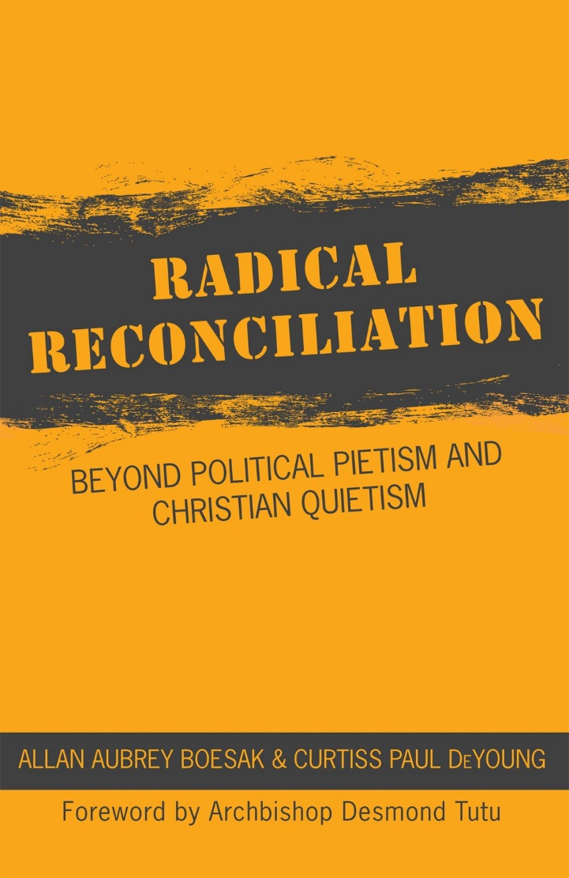

Radical Reconciliation
A book study for Lent – Part Three

Week Three – Beloved Communities Restored
Prayer to start
Gracious and loving God,
Who in Christ reconciles the world to yourself.
May we be those who, reconciled within ourselves and our communities,
Reach out in love and justice to bring transformation to your world.
In the name of Christ, the reconciler,
Who with you and the Spirit of Life
Exist in loving relationship,
Now and in all eternity. Amen.

Bible Reflections – Galatians 3
²⁷As many of you as were baptized into Christ have clothed yourselves with Christ. ²⁸There is no longer Jew or Greek, there is no longer slave or free, there is no longer male and female; for all of you are one in Christ Jesus. ²⁹And if you belong to Christ, then you are Abraham’s offspring, heirs according to the promise.
As in our first week – read this out loud, then pause for a minute or two, then read it again.
- What words or phrases stand out for you?

Then you may wish to tackle these questions

- What does it mean to be ‘all one in Christ Jesus’?
- Who is included in this statement?
- What might this say to our work of reconciliation and healing?

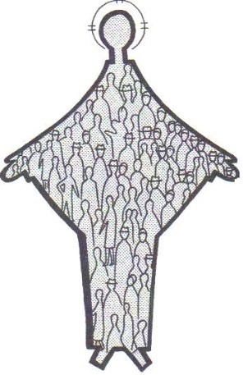
Restoring the Beloved Community

“Ultimately, the unity of the first century church was the result of the miracle of reconciliation – a conversion from their ethnocentrism to the intention, practice, and vision of Jesus.” p 79
Reconciliation will begin in ourselves and in the Church. In what ways do you feel able to talk about conflicts in your own Christian community?
The early Church was made up of the colonised and the colonisers, that balance is not so much the case in the Canadian Church today.
- If we as a Christian community are dedicated to reconciliation how might we begin to give voice to the margins today?
- Are there those who we could describe as ‘the colonised’ in leadership in our communities?
  - If not, how might we achieve that, if so how did that happen in your church?
“In Palestine the first-century Church was under Roman occupation. So the mother church of Christianity in Jerusalem had very limited meaningful contact with persons outside the Jewish community .” P83
- Where are our points of contact with those beyond our own ethnicity, social circles, or culture?
“Gentile Christians (had) to defect from their own entitlements and loyalties.” P 81, Quoting Myers & Enns (2009)
Our societies attention has been drawn in recent years to the concept of ‘privilege’ experienced particularly by white people and especially men. What do you think is meant by privilege and how does that idea make you feel? In what ways do our churches, and many members of our communities experience ‘entitlements’?
Implicit in the project of reconciliation for those of us who are descended from ‘settlers’ is an acknowledgement of our ongoing, albeit maybe unintentional, perpetuation of structures and systems which continue to disadvantage persons of colour, Indigenous people, women, people in poverty, and those with little or no formal education. How does such a critique make you feel?
“Relationships between women and men, the colonized and the colonizer, and marginalized and privileged were being reconciled through the Spirit’s power of reversal. Yet the healing process of reconciliation was often challenging and disruptive” (p 84)
- In what ways do you feel reconciliation in and through our church communities might be disruptive and disturbing?
- Does this concern you? Excite you? Inspire you?
- Is there anything you might be afraid of in this process?
- How might we as Christian communites prepare for this, or be open to this – the church is not renowned for it’s embrace of change?
“Rather than transforming society through a process of reconciliation, congregations have overwhelmingly conformed to a racialized, patriarchal, and class-based society” p.85
Does this ring true for you in your situation? If not, why not? If so, what can/will you do about this? How can we be transformed in order that we might effect transformation?
Implementing a process of reconciliation
The authors talk of Congregations being ‘places of healing for persons marginalized in society’ but in the list of ways in which society makes people feel marginalised they say it is because of “race, gender, class, sexual orientation, ability, age, religion, lifestyle choices, life circumstances, and the like.” – the Church has, and often still does, perpetuate such marginalisation, or at least has a reputation for judging people due to many of the above factors.
- What is there in our community of faith that we need to repent of?
- How do we share a Gospel of welcome and acceptance, of affirming and celebrating in such a way that all feel they are welcome to join ‘the body of Christ’?

“The end is reconciliation, the end is redemption, the end is the creation of the beloved community” Martin Luther King Jnr
Between Reitz, a Rock, and a Hard Place
The terrible events at the University of the Free State where white students humiliated black staff and circulated video of it as a ‘comment’ on integration caused South Africans to ask ‘is this the country we want to be?’
Could we ask the same question of our Church? Are we living as the people we want to be? Are we transformed and transforming communities of Christ-likeness?
- What are the barriers to being such a community?
- What do you resolve to do in order to bring about such change?
- How does our praying and serving together foster such transformation?
The voice of the Church to the world
If we are transformed and transforming communities we will speak out and live reconciliation, we will challenge the society around us to consider its own use and misuse of power and seek to change the status quo.
“A reconciliation process in which the established power dynamics are not challenged, and shifted, but instead subtly or not so subtly reaffirmed, is doomed to fail.” P95
- Are we (individually or in our communities) actively challenging attitudes in our society which dehumanise or marginalise?
- How can the Church at large, and our individual churches, seek to challenge the power structures which prevent the realisation of reconciliation?

“To wash one’s hands of the struggle between the powerful and the powerless is to side with the powerful, not to remain neutral” Paolo Friere
To Stand Where God Stands
“…the church, as possession of God, should stand where God stands, namely against injustice and with the wronged: that in following Christ the church must witness against all the poweful and privileged who selfishly seek their own interests and thus control and harm others” The Belhar Confession, Uniting Reformed Church in Southern Africa
- Is this how we see the work and calling of the Church?
- What does it mean to ‘stand where God stands’?
- How might we realistically begin to do that in our current situations?
If reconciliation, as the first chapter posited, involves ‘exchanging’ with the oppressed, the dispossessed, the downtrodden, we are called as Christ’s people to seek to do that. We are called to ‘exchange’ with those to whom we seek to be reconciled.
What concrete actions are we going to take to do this?
Summing up
Take some time to discuss what this session has brought to you, and what you have brought to it. Are there questions to take with you? New things to think about? Concerns you have? Hopes you have?
What are you going to do next? What are we going to do with these things?
Prayer to close
For all that we have learned,
for those things which have challenged, disturbed, excited, surprised us
we give you thanks.
We pray for open hearts and open minds,
That we may build our faith not on empire
But on Jesus Christ, our reconciler. Amen

