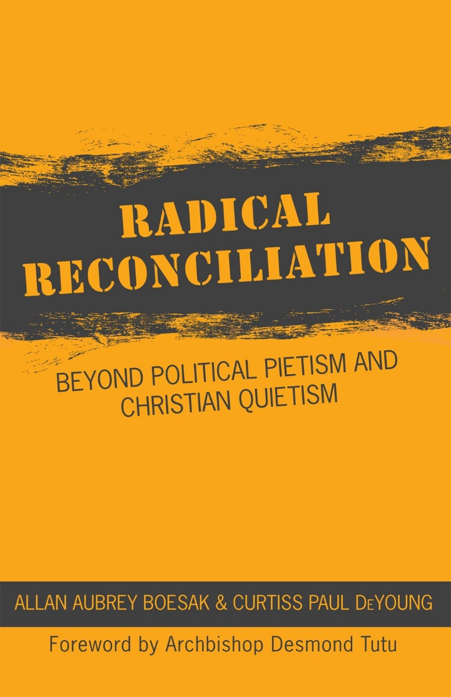

Radical Reconciliation
A book study for Lent – Part Two

Week One – Reconciliation Redefined
Prayer to start
Gracious and loving God,
Who in Christ reconciles the world to yourself.
May we be those who, reconciled within ourselves and our communities,
Reach out in love and justice to bring transformation to your world.
In the name of Christ, the reconciler,
Who with you and the Spirit of Life
Exist in loving relationship,
Now and in all eternity. Amen.

Bible Reflections – Luke 4
¹⁴ Then Jesus, filled with the power of the Spirit, returned to Galilee, and a report about him spread through all the surrounding country. ¹⁵He began to teach in their synagogues and was praised by everyone.
¹⁶ When he came to Nazareth, where he had been brought up, he went to the synagogue on the sabbath day, as was his custom. He stood up to read, ¹⁷and the scroll of the prophet Isaiah was given to him. He unrolled the scroll and found the place where it was written:
¹⁸ ‘The Spirit of the Lord is upon me,
because he has anointed me
to bring good news to the poor.
He has sent me to proclaim release to the captives
and recovery of sight to the blind,
to let the oppressed go free,
¹⁹ to proclaim the year of the Lord’s favour.’
²⁰And he rolled up the scroll, gave it back to the attendant, and sat down. The eyes of all in the synagogue were fixed on him. ²¹Then he began to say to them, ‘Today this scripture has been fulfilled in your hearing.’
Jesus begins his ministry with a strong statement – one which lays out his ‘agenda’ in ministry, and therefore one which we, as the Church, should take seriously. So here are some questions to begin our thinking processes:
- What is good news for the poor? Freedom for the oppressed and the prisoner?
- Who are ‘the blind’ who need to recover their sight? Is that us?

An exercise in imagination
Pictures of Jesus: which ones appeal? Or disturb?

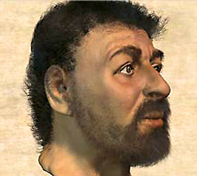
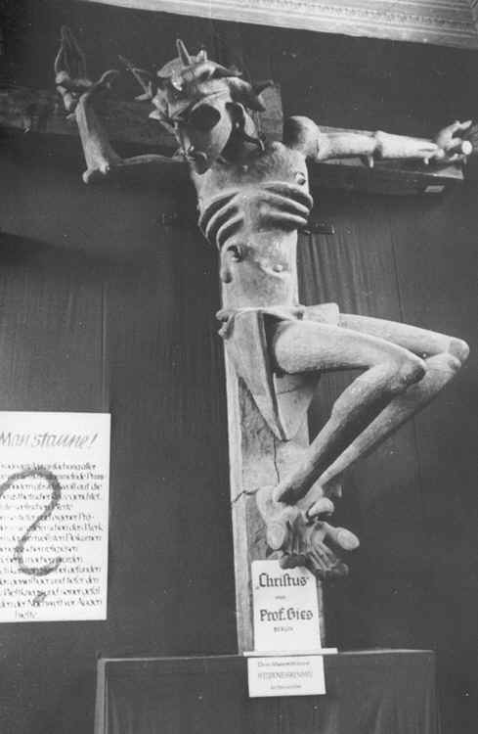
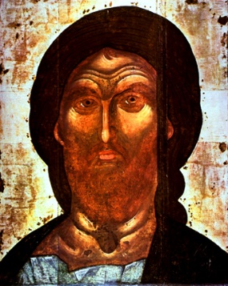
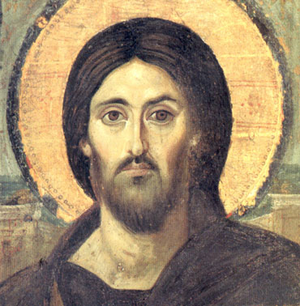
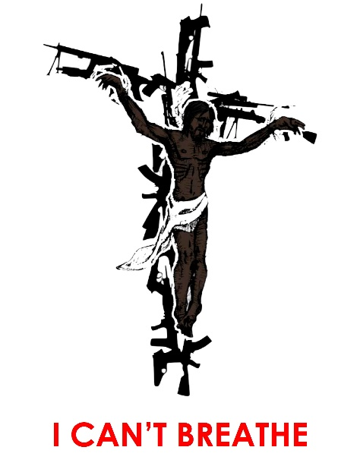

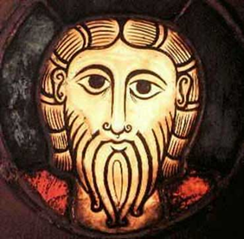
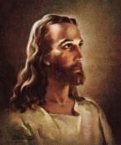
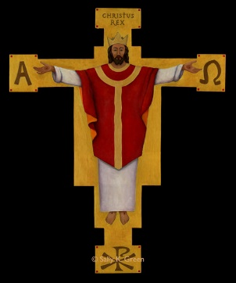
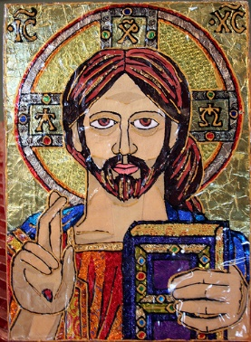
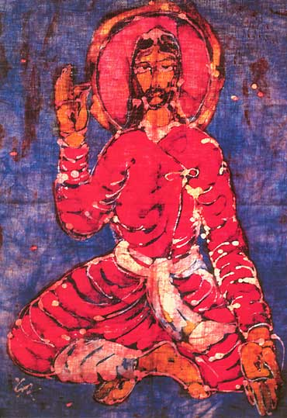
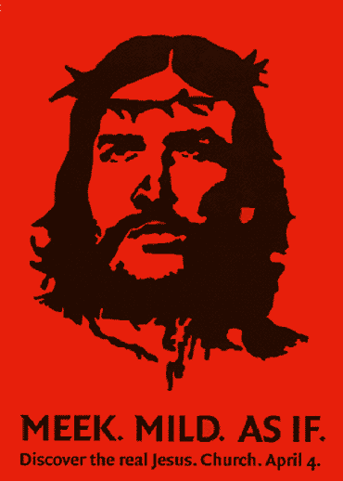
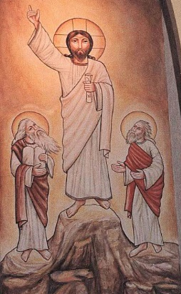
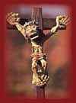
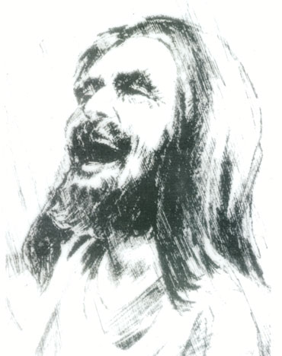

From where do we get our ‘images’ of Jesus?
Have we allowed our own ‘cultural biases’ or prejudices to influence the way we see Jesus? Are we uncritical of our own culture in creating such pictures?
“Jesus upbringing in Galilee was shaped by the realities of colonization and occupation” (p 45)

“Sometime after yesterday and before today, his (Jesus’) life story was co-opted, reconfigured, and reissued. The story of a colonized and occupied Jesus was replaced with a meek and mild savior who did not disrupt the status quo or with the image of a colonial Christ who sided with the powerful and blessed imperial realities.” p 49

- Have we ever thought of Jesus as a victim of colonisation? One who spoke out against Caesar and used Hebrew Scripture to challenge the artifice and power of empire? Do with think of the cross as a sacrifice to the power of empire?
“Jesus developed real relationships with those at the margins.” p 46
- How might we do that in our churches today?
Jesus did not only criticise those who held power and privilege, he engaged with them and brought them into the idea of the ‘Kingdom of God’ – a new kingdom where the God of love and justice occupied the throne of Caesar. “While life in the oppressive conditions of Galilee may have negatively affected Jesus, his upbringing in the multicultural, multilingual “Galilee of the nations” (or “Galilee of the Gentiles”) provided a context where he could be shaped with strong reconciliation instincts.
- How might we engage with the different cultures in our society and integrate those voices into our story of reconciliation?

“A white European colonial image of Jesus was constructed, owned, and manipulated by empires for domination.” P49
- Is our image of Jesus white?
- Do we believe that somehow Jesus particularly blesses one race or nation above others?
- Could we envisage a Black, Latino, First Nations, Asian, Indian, Arab, or Semitic Jesus?
- Why might it be important to be able to see Jesus in these different ways? Or why do we struggle with such an idea, or even find it offensive?

“those wishing to ground their understanding of reconciliation within the Christian tradition are forced to deal with the figure of Jesus Christ.” Miguel de la Torre (p 57)
- What is our picture of Jesus – the person of ‘Incarnated Reconciliation”?
Quoting St Paul in Ephesians, Jesus is described as “emptying himself, taking the nature of a servant” – words which the author says have been ‘far too often mystified into doctrinal, pietistic metaphysics, fatally removed from the understanding and life of ordinary Christians and a world in desperate need of justice and reconciliation.”
- Do we find ourselves drawn to a ‘mystical Jesus’, or ‘an incarnated, flesh-bound Jesus’?
- Do these need to be contradictory pictures?
- How can we hold these together?

Just another Jew in the Ditch+
The authors talk of Jesus as ‘Incarnated Reconciliation’ – what does that phrase mean to you?
In Jesus God responds to the cry of the prophet Isaiah ‘O that you would tear open the heavens and come down’ (Isaiah 54.1) – the longing for God to intervene in human affairs when all other hope feels lost. Yet in Jesus this expectation is turned upside down – when God in Christ ‘emptied himself, taking the very nature of a servant’ (Ephesians 2.7). This means Jesus identifies not with the powerful, but the weak – being a susceptible to the pain and oppression of racism and imperial power as any other Jewish subject of empire.
- Can you think of any other well known Christian (or other) figures who inspire you with their radical identification with the poor?
- How might we as a Church emulate such people?
In Jesus, there is a declaration of a radical re-ordering of society – with the picture of the poor being at the bottom and the privileged at the top.
- “The import of this is unmistakeable. For the coming of justice it is not sufficient to raise the ones at the bottom, leaving everything else the same. Something must also happen to those at the top: they must be cast down.” Wolderstorff
- Is the Church willing to proclaim such a prophetic word? What are the obstacles? What are fears?
- Do we recognise our own place of privilege in this order?
As we read of the encounter with Zacchaeus the tax collector we are reminded of the need for restitution and forgiveness within reconciliation. We are challenged to consider reconciliation is a spiritual as well as a political process, and one that has demands for social justice inherent in the process. This is the transformation of reconciliation – and we are called to declare and to live it.
The author gives ten lessons that the salvation Zacchaeus receives teaches: Reconciliation can not be shallow. Reconciliation is impossible without remorse. Reconciliation is not cheap. Reconciliation must have equality. Reconciliation is about restoring broken relationships with others and our community. Reconciliation involves public recompense. Reconciliation involves uncovering ‘the sin.’ Reconciliation brings more than just individual salvation. Reconciliation ‘switches sides’. Reconciliation brings a new identity.
- Which of these do you find most striking or challenging?
- Are there any you feel to be impossible?
- Can you think of any particular instances of reconciliation – at home, in your spiritual community, in our country – where any, or all, of these aspects have been visible and tangible?
- Where is Canada now with respect to those ten steps?
- Where is the church?
Summing up
Take some time to discuss what this session has brought to you, and what you have brought to it. Are there questions to take with you? New things to think about? Concerns you have? Hopes you have?
What are you going to do next? What are we going to do with these things?
Prayer to close
For all that we have learned,
for those things which have challenged, disturbed, excited, surprised us
we give you thanks.
We pray for open hearts and open minds,
That we may build our faith not on empire
But on Jesus Christ, our reconciler. Amen

